User Manual

**1 General**

1.1 System Overview . . . . . . . . . . . . . . . . . . . . . . . . . . . . . . . . . . . . . . 3

1.2 Contact . . . . . . . . . . . . . . . . . . . . . . . . . . . . . . . . . . . . . . . . . . . 3

**2 Getting Started**

2.1 Getting started . . . . . . . . . . . . . . . . . . . . . . . . . . . . . . . . . . . . . . . 4

2.2 System Requirements . . . . . . . . . . . . . . . . . . . . . . . . . . . . . . . . . . . 4

**3 Normal User**

3.1 Creating an Account . . . . . . . . . . . . . . . . . . . . . . . . . . . . . . . . . . . . 7

3.1.2 Logging into System . . . . . . . . . . . . . . . . . . . . . . . . . . . . . . . . . . . 9

3.1.3 Logging Out . . . . . . . . . . . . . . . . . . . . . . . . . . . . . . . . . . . . . . . . . 10

3.5 Language Selection . . . . . . . . . . . . . . . . . . . . . . . . . . . . . . . . . . . . 11

3.6 Search . . . . . . . . . . . . . . . . . . . . . . . . . . . . . . . . . . . . . . .. . . . . . 12

3.7 Club Interaction . . . . . . . . . . . . . . . . . . . . . . . . . . . . . . . . . . . . 12

3.7.1 Access Club Page Or School Department Page . . . . . . . . . . . . .. 12

3.7.2 Club Page Navigation

3.7.2.1 Comments . . . . . . . . . . . . . . . . . . . . . . . . . . . . . . . . . 12

3.7.2.2 Group Chat . . . . . . . . . . . . . . . . . . . . . . . . . . . . . . . . . 12

3.7.2.3 Join Event . . . . . . . . . . . . . . . . . . . . . . . . . . . . . . . . . . . . 12

3.7.2.4 Apply for joining a club . . . . . . . . . . . . . . . . . . . . . . . . . . . . . . . . . 12

3.8 Dynamic Moments. . . . . . . . . . .. . . . . . . . . . . . . . . . . . . . . . . . . .. . . . .12

3.9 Daily Recommended. . . . . . . . . . .. . . . . . . . . . . . . . . . . . . . . . . . . .. 12

3.9.1 Events. . . . . . . . . . .. . . . . . . . . . . . . . . . . . . . . . . . . .. . . . .. . . . . 12

3.9.2 Clubs. . . . . . . . . . .. . . . . . . . . . . . . . . . . . . . . . . . . .. . . . .. . . . .12

3. 9.3 Website Recommendation . . . . . . . . . . . . . . . .. . . . .. . . . .12

4.0 Update Personal Information. . . . . . . . . . . . . . . .. . . . .. . . . .12

4.1 Personal Activity Schedule. . . . . . . . . . . . . . . .. . . . .. . . . .12

4.2 Activity Reminder. . . . . . . . . . . . . . . .. . . . .. . . . .12

5.0 Extra Entertainment. . . . . . . . . . .. . . . . . . . . . . . . . . . . . . . . . . . . .. 12

**Chapter 1**

**General**

* 1. System Overview

This system is an interactive platform between students and clubs for University Of Liverpool. It consist information update and integration system, user recommendation system, dynamic information sharing and viewing system, club activities registration and subscription, comment and chatroom.

* 1. Contact

**Chapter 2**

**Getting Started**

2.1 System Overview

Welcome to moment website! Through this platform, you will have nice experience to deeply contact with university’s clubs and department, leaving your comments, sharing your opinions and knowing the latest events. You also can share your moments or information on this platform, like an on-campus size of Twitter.

2.2 System Overview

There are minimum 2 requirements for the system.

• An internet connection

• Any up-to-date browser

**Chapter 3**

**Normal User**

3.1 Creating an Account



There is a “Register” button on the right corner of the navigation bar at the top of home page. Click and jump to the information filling page. Username, password, and university email address are required. You need to remember your user name and password after registration. Please note that user name and email address cannot be repeated with others.

3.1.2 Logging into System

After registration you can use your user name and password to log into the system by clicking the “Log in” button at the top navigation bar of pages. The login window will appear as follow. When you have successfully log in, your user name will replace the “log in” button.

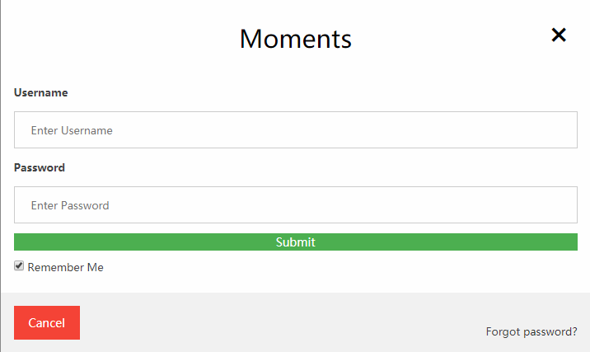

3.1.3 Logging Out

3.5 Language Selection

We also provide language transformation function. You can find it in navigation bar behind log in button and click to select language. Currently, our web only have English and Chinese version.

QQ图片20190406055751

3.6 Search

You are free to use the searching bar in each page to search for an interested club, an club event, or a user name by enter related key words.

And ten 10 hottest topics will be ranked when you click the searching bar, which will updates daily.

Note that the search bar exist at top in most pages of this web.

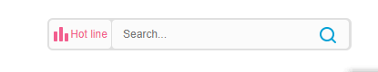

3.7 Club Interaction

3.7.1 Access A Club Page Or Department Page

You can access by 3 different ways.

1. Directly using the searching bar to search for the name.
2. Access home navigation bar and click the ”Society” button. You will be able to see a series of club categories including physics, academy, technology, culture, association, social services, and art. Each of them will lead you to the a list of clubs under this category.

Similarly, if you want to contact to the University Department and want to access the official page, you can click the “University” button nearby the “Society”.

QQ图片20190406073609

3.7.2 Club Page Navigation

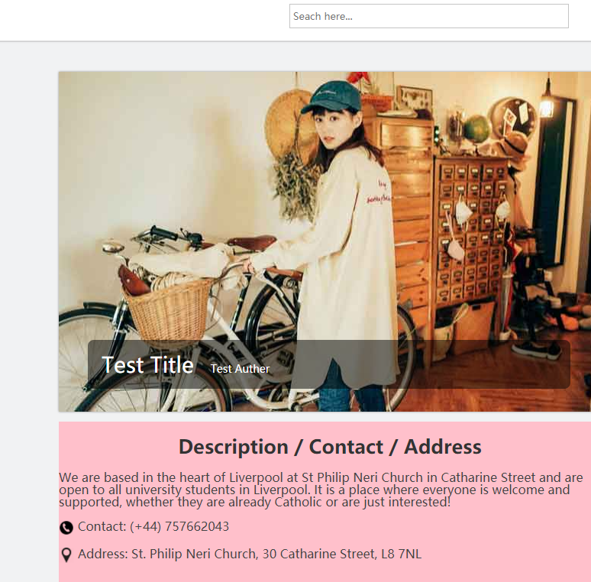

You can clearly view basic club description information including representative graphics, name, contact number and address at left-hand page.

If you drop down the page, you will view the names of club members.

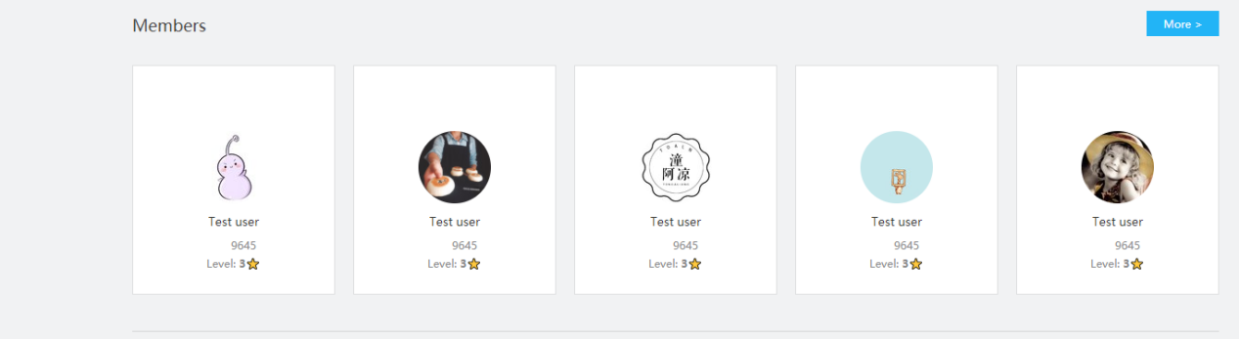

The level of stars represent the authority of this member in club. Level 3 represents administrative authority.

3.7.4 Group Chat

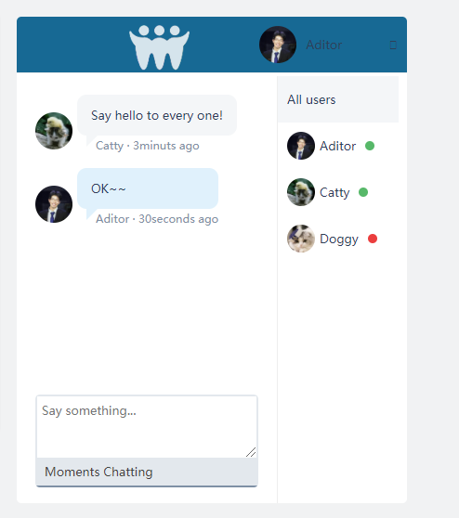

An temporary dialog box is placed on each club page. User who enter the club page can join a temporary session.

3.7.5 Apply For Joining a Club

If you want to participate a club, you can click the “Apply for participation” button below club description information.

The request will be sent to the club manager. If the club manager view the message, he/she will inform you by email with details.

3.7.3 Join Events

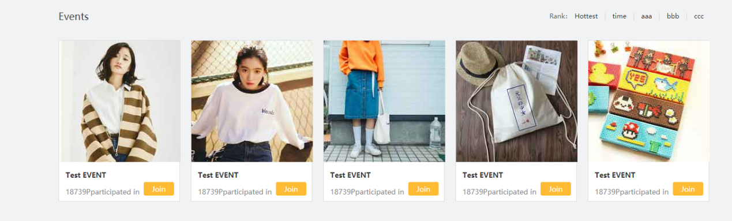

The events slides on club page shows the current/upcoming/previous club activities. If you are interested in and want to know more, you can click the image to enter a new page which allow you to see the event details(shown as below)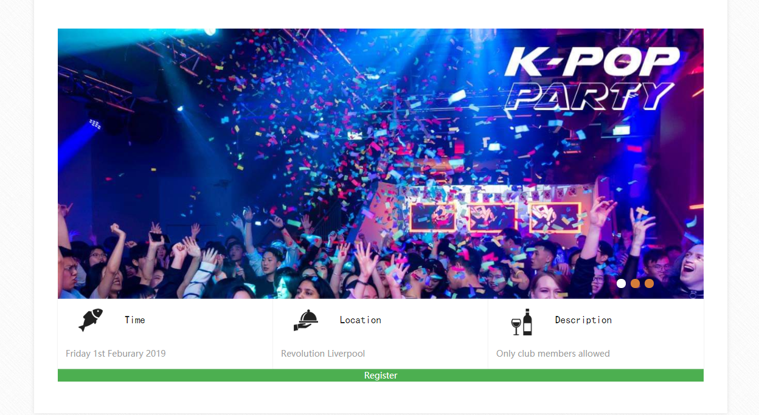

You will enter the activity related page once you click your interested activity from events slides. And you can know the time, location as well as the activity description. Click the green panel “Register” to sign up for the activity. Once you do that, your name will be added to activity participants list hold by club manager. In addition, a new schedule will be added to your personal schedule list and remind you automatically 2 days before the event.

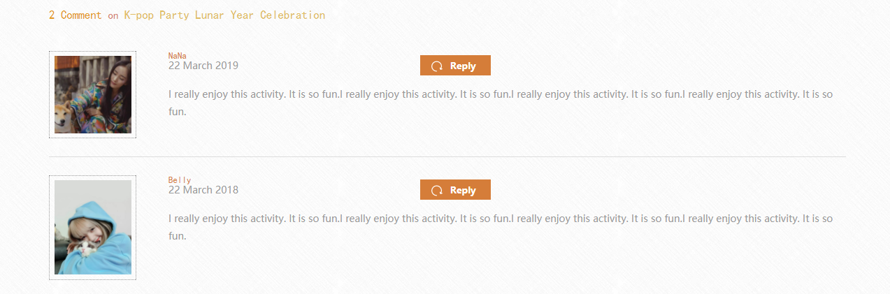

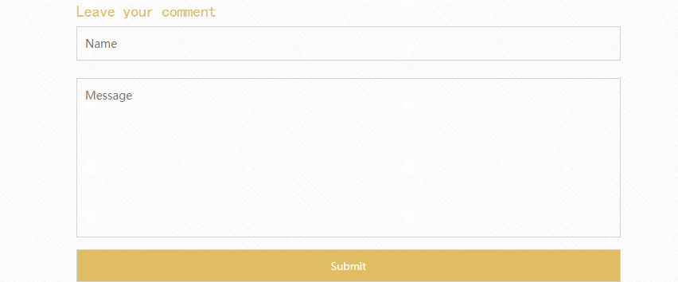

Dropping down, You'll see a message board about the event. You can respond to other people's messages or submit your own.

Or you can just click on the yellow panel “Join” to join the activity directly without enter a new page. Once you do that, your name will be added to activity participants list hold by club manager. In addition, a new schedule will be added to your personal schedule list and remind you automatically 2 days before the event, which you can check in your personal information page. To know more about this function, please check details of 4.0, 4.1 and 4.2 in directory.

3.8 Dynamic Moments

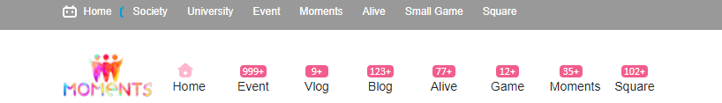

Back to the main page, if you click the “Moment” button in the navigation bar , you will be directed to a new page. This page contains live moments from other users, like Twitter. You can write your own moments and post them. It would be useful when you want to organize an activity/find a lost item/spread a news in campus.

Numbers above the button with pink surroundings counts the numbers of new updates which you have not glanced yet.